**Documentation – Practical work no. 3**

For graph1k:

Lowest cost walk between 1 and 100 is 141

**Graph 1:**

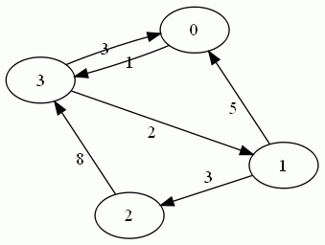

Compute distance between 1 and 3

Start = 1

End = 3

n = 4

w = [[INF, INF, INF, INF, INF],

[0, INF, INF, INF, INF],

[INF, INF, INF, INF, INF],

[INF, INF, INF, INF, INF],

[INF, INF, INF, INF, INF]]

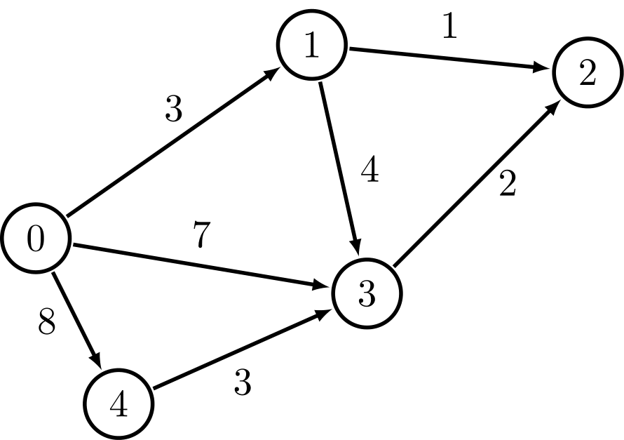k = 0

i = 0

v = 3

w [3][1] = INF

i = 1

v = 0

w [0][1] = 5

v = 2

w [2][1] = 3

i = 2

v = 3

w [3][1] = INF

i = 3

v = 0

w [0][1] = INF

v = 1

w [1][1] = INF

w = [[INF, 5, INF, INF, INF],

[0, INF, INF, INF, INF],

[INF, 3, INF, INF, INF],

[INF, INF, INF, INF, INF],

[INF, INF, INF, INF, INF]]

k = 1

i = 0

v = 1

w [1][2] = INF

v = 3

w [3][2] = 6

i = 1

v = 0

w [0][2] = INF

v = 2

w [2][2] = INF

i = 2

v = 3

w [3][2] = min (6, 11) = 6

i = 3

v = 0

w [0][2] = INF

v = 1

w [1][2] = INF

w = [[INF, 5, INF, INF, INF],

[0, INF, INF, INF, INF],

[INF, 3, INF, INF, INF],

[INF, INF, 6, INF, INF],

[INF, INF, INF, INF, INF]]

k = 2

i = 0

v = 1

w [1][3] = INF

v = 3

w [3][3] = INF

i = 1

v = 0

w [0][3] = INF

v = 2

w [2][3] = INF

i = 2

v = 3

w [3][3] = INF

i = 3

v = 0

w [0][3] = 9

v = 1

w [1][3] = 8

w = [[INF, 5, INF, 9, INF],

[0, INF, INF, 8, INF],

[INF, 3, INF, INF, INF],

[INF, INF, 6, INF, INF],

[INF, INF, INF, INF, INF]]

k = 3

i = 0

v = 1

w [1][4] = INF

v = 3

w [3][4] = 10

i = 1

v = 0

w [0][4] = 13

v = 2

w [2][4] = 11

i = 2

v = 3

w [3][4] = INF

i = 3

v = 0

w [0][4] = 13

v = 1

w [1][4] = INF

w[end] = w [3] = [INF, INF, 6, INF, INF]

Minimum cost path is 6

**Graph 2:**

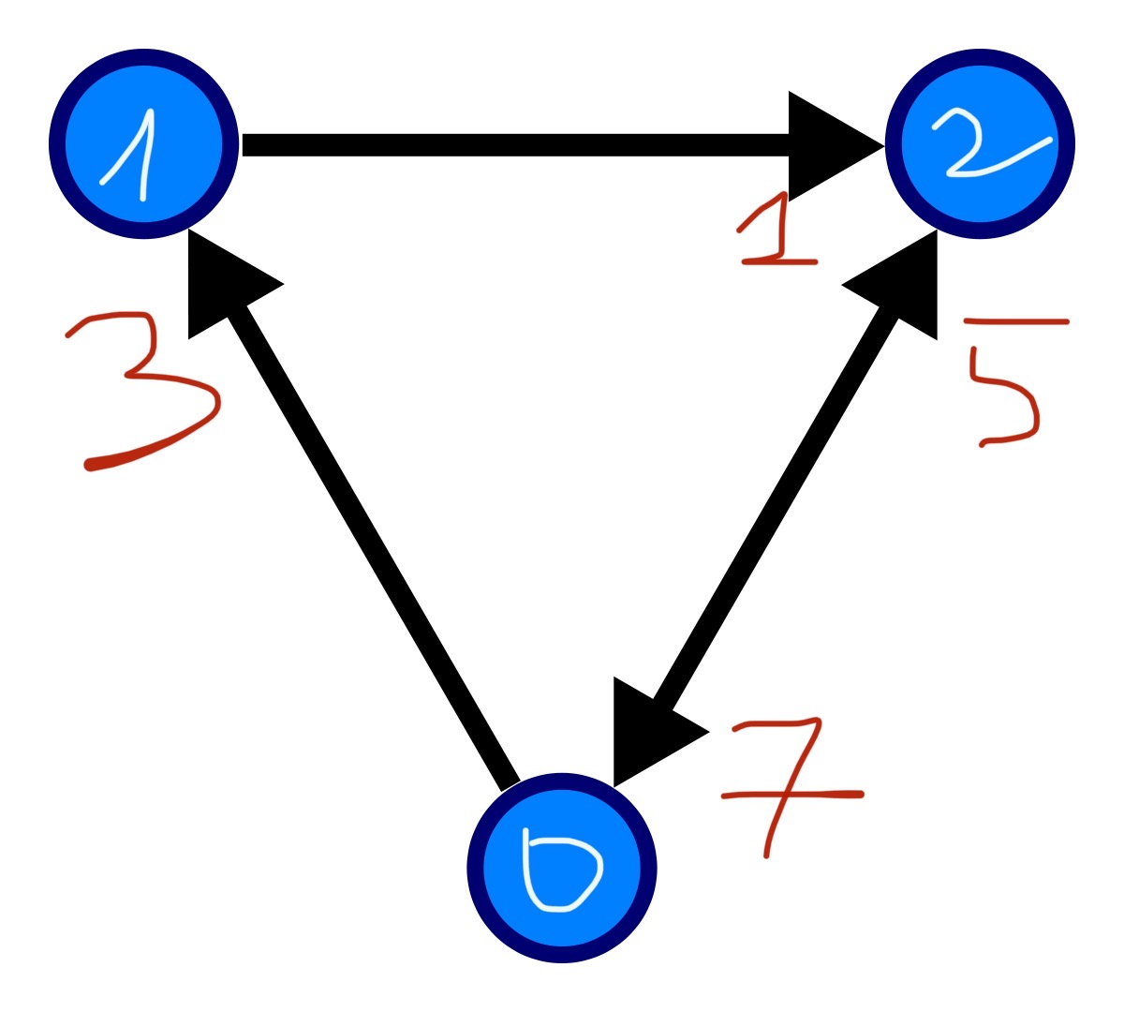

Cost between 0 and 2

Start = 0

End = 2

N = 3

W = [[0, INF, INF, INF], [INF, INF, INF, INF], [INF, INF, INF, INF], [INF, INF, INF, INF]]

k = 0

i = 0

v = 1

w [1][1] = 3

v = 2

w [2][1] = 5

i = 1

v = 2

w [2][1] = 5

i = 2

v = 0

w [0][1] = INF

W = [[0, INF, INF, INF], [INF, 3, INF, INF], [INF, 5, INF, INF], [INF, INF, INF, INF]]

k = 1

i = 0

v = 1

w [1][2] = INF

v = 2

w [2][2] =INF

i = 1

v = 2

w [2][2] = 4

i = 2

v = 0

w [0][2] = 12

W = [[0, INF, 12, INF], [INF, 3, INF, INF], [INF, 5, 4, INF], [INF, INF, INF, INF]]

k = 2

i = 0

v = 1

w [1][3] = 15

v = 2

w [2][3] = 17

i = 1

v = 2

w [2][3] = 17

i = 2

v = 0

w [0][3] = 11

W = [[0, INF, 12, 11], [INF, 3, INF, 15], [INF, 5, 4, 17], [INF, INF, INF, INF]]

w [end] = w [2] = [INF, 5, 4, 17] => minimum cost path between 0 and 2 is 4